# JIRA Quick Start Guide

You may use CITnet's JIRA issues for:

* Any support question on the software or the procedure (i.e. Pilot-phase),
* bugs in VECTO-tools, or
* general ideas for discussion,

To submit a new issue, click the "Create" button at the top-bar:  
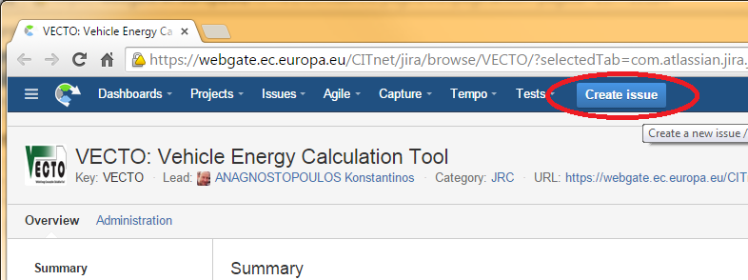

Fields are needed (marked with (star) those required when creating an issue):

* **Issue-Id:** Created after you save the issue, and it has the form "VECTO-13". It is appended at the beginning of every thread-title,and it is used as a reference throughout external-systems and/or emails.
* **Issue-type(star):** Required to select one of the following when creating an issue:
  + **BUG** (If unsure, select this)
  + **Improvement**
  + **New feature**
  + **Support** - questions about CITnet, user-permissions, administrative
  + **Task** - non-software related activities (i.e. PilotPhase)
* **Summary(star):** A descriptive phrase giving a clear explanation the issue, to be used as Title.
* **Description(star):** Detailed description of the issue; rich text formatting maybe used.
* **Components:** One of: Simulator, CSE, Infrastructure, Administrative, ...  It is used to select automatically an **Assignee**.

## JIRA Workflow

The following workflow elements are used to communicate the progress on an issue:

* **Status:**It may be: DRAFT, OPENED, IN PROGRESS, ..., RESOLVED, INVALID, CLOSED, and others, depending on its **Issue-type**. Users change it to signify work-progress. For instance, Issues are considered completed when they are Closed.
* ***Comments:*** A series of '***Comments***', that describe the job performed for accomplishing the bug and ANY user feedback. These correspond to the replies in the mailing-list analogy.
* **Files and Screenshots**
* The '***People***' are different fields specifying users to be notified with emails for all changes and comments on the issue.
* ***Assignee***: The person currently responsible to respond or to make some job for the issue to proceed. After an assignee performs its tasks, **he should re-assign the task to whoever should next take charge of the issue.** If unsure, assign to the component-owner or to some manager.

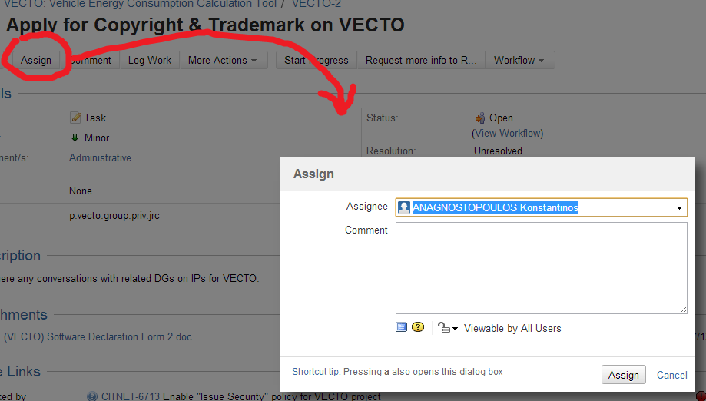

* ***Reporter***: The user that has initially created the issue.
* ***Watchers***: Users who are to receive emails on every change. You can add yourself as a Watcher to any issue.

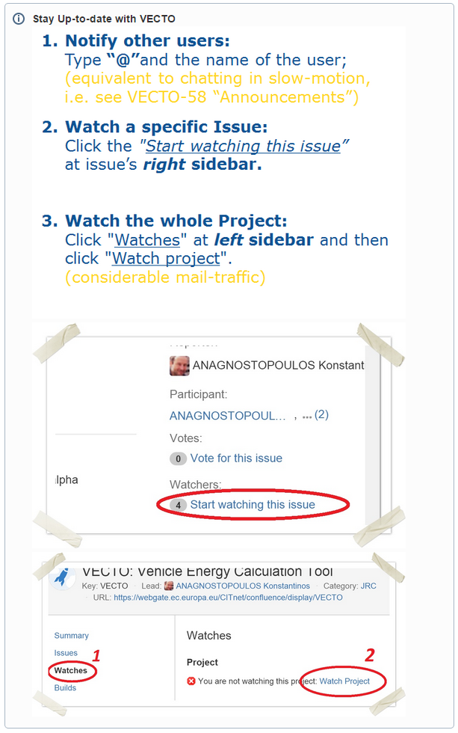

For more information visit the VECTO wiki:

[**https://webgate.ec.europa.eu/CITnet/confluence/display/VECTO/JIRA+Overview**](https://webgate.ec.europa.eu/CITnet/confluence/display/VECTO/JIRA+Overview)